**Exercise: Client – Server communication**

In this exercise, you will use sockets and TCP to send data between two programs, a client and a server.

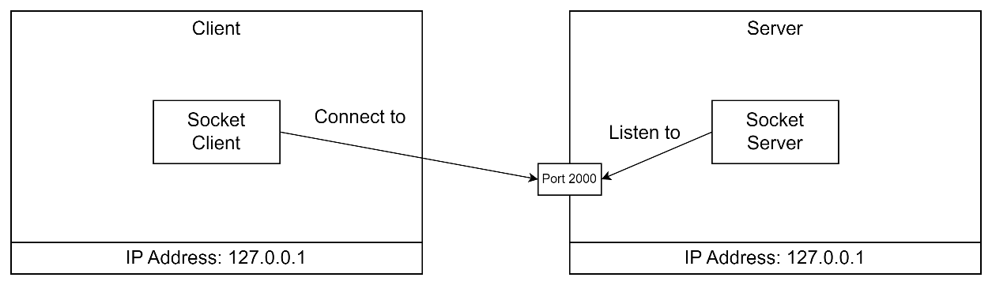

**Exercise 1:**

Create two .NET solutions: A client and a server. Both should be a console application.

The server shall listen for incoming connections on port 2000.

It shall print the data it receives and send a reply to the client.

The client shall connect to the server on port 2000.

It shall send a message to the server and print the reply it receives.

Run both client and server on the same PC and use the loopback address.